Carrier Update

There are two new reports available, the ***1287*** report which will give you your Acceptance/Reject %.  You can pull this by origin state, Destination ID, or All *.

**1287 Instructions:**

When you log on, enter credentials then click Print and it will prompt you to enter dates:

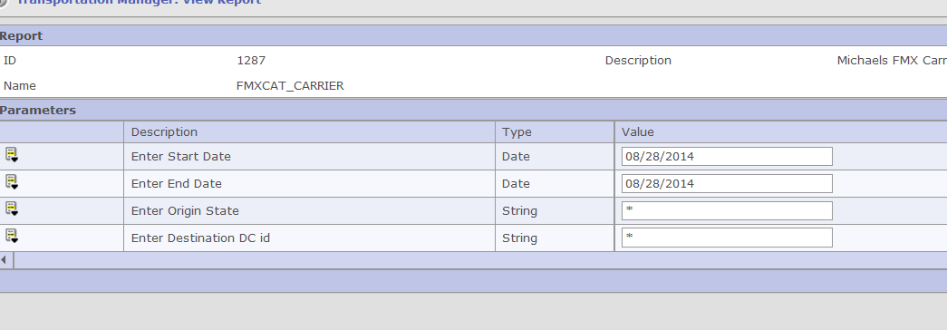

Once you enter dates it should run.

**1288 Instructions:**

There is also a new report ***1288*** that lets you pull the dedicated report based off Service, so for example you only wanted to see 01RG loads you would enter 01RG:

When you log on, enter date range, click Print/Submit and it will run.

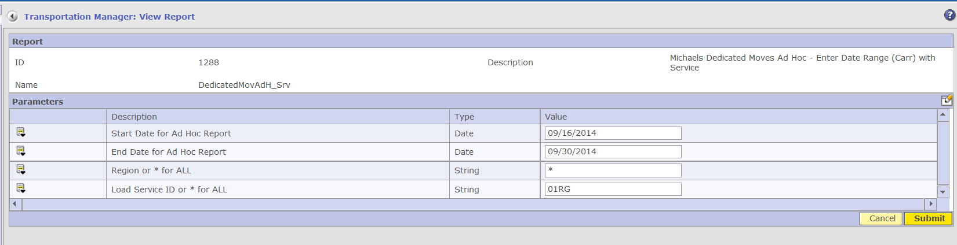

***Please contact*** [***Pavnicaa@michaels.com***](mailto:Pavnicaa@michaels.com) ***for further help if you are unable to view the Report .***